PATENT QUOTATION
Dated: 12/08/2025
~ To whomsoever it may concern ~

Quotation Prepared by: Adv. Pranav Bhat
Contact Details: 9035685434
Email: info@lextria.in / pranavbhat@lextria.in
Sl. No | Particulars | Cost (Govt Fee + Prof Fee + Misc.)
1. | Design search with oral opinion, Representation Sheet preparation, drafting, filing & Response to Examination Report (FER) (If objections are raised by the Design Office) along with Attending hearing and filing written submission (If required) | 4000+ 15,000 + 1,000 = 20,000/-

Notes:
- An 18% GST will be applied to the professional fees.
- In case a similar quotation is required again for any other service, kindly reach out to us, and we will be happy to assist you.
- Any additional reimbursements, if applicable, will be informed to you priorly for your approval before proceeding.
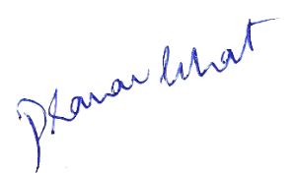
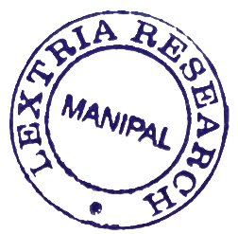
Should you have any questions or require further clarification, please feel free to contact us at the provided email or phone number. Thank you for considering our services. We look forward to assisting you with your intellectual property needs.

Best Regards,
Adv. Pranav Bhat, Chief IP Strategist
Lextria Research

